Health Insurance Claim Management System for Chen’s Chinese Medicine

Pan Chen Syracuse University

**Project Summary**

This is a revised version of the summary in your project design report. Please revise according to the suggestions provided by the instructor and fellow students.

I have designed a Health Insurance Claim Management System for my aunt, who runs a clinic in Camarillo, CA called Chen’s Chinese Medicine. The current one she is using is not too easy to navigate and not efficient enough: it has too much functions/options that an acupuncture clinic does not need, so it takes extra time to navigate through these redundant options input each patient’s entry. So a simple design that focuses on the insurance billing might be a good start point for my project.

My aunt is the only practitioner in the clinic with several staff members that helps her with insurance claim filing and billing. This project is set to help the clinic manage the patient’s payment to each office visit, which records the patient information and his/her insurance policy information, his/her office visits including appointment date and the description of the treatment he/she received, insurance claims information associate with his/her visits including their statuses, claim amount, and which staff member handles the claim, and the clinic staff’s information.

The design is for two user groups. One is for the business owner/the practitioner, the other one is for the staff members.

Both business owner and staff members could check/edit the information for the patients, their insurance policy information, their clinic visit information, the statuses of the insurance claims. The business owner could also check the summary of the staff members and the claims they are working on.

Questions

* How many claims are associated with each patient? What are they?
  + **How many claims are handled by each staff member? What are their statuses?**
  + **ADD MORE!!!!!**

**Section III**: entity and attribute glossary and relational data model in both ACCESS (Relationship Diagram) AND ERD in Visio (2 point)

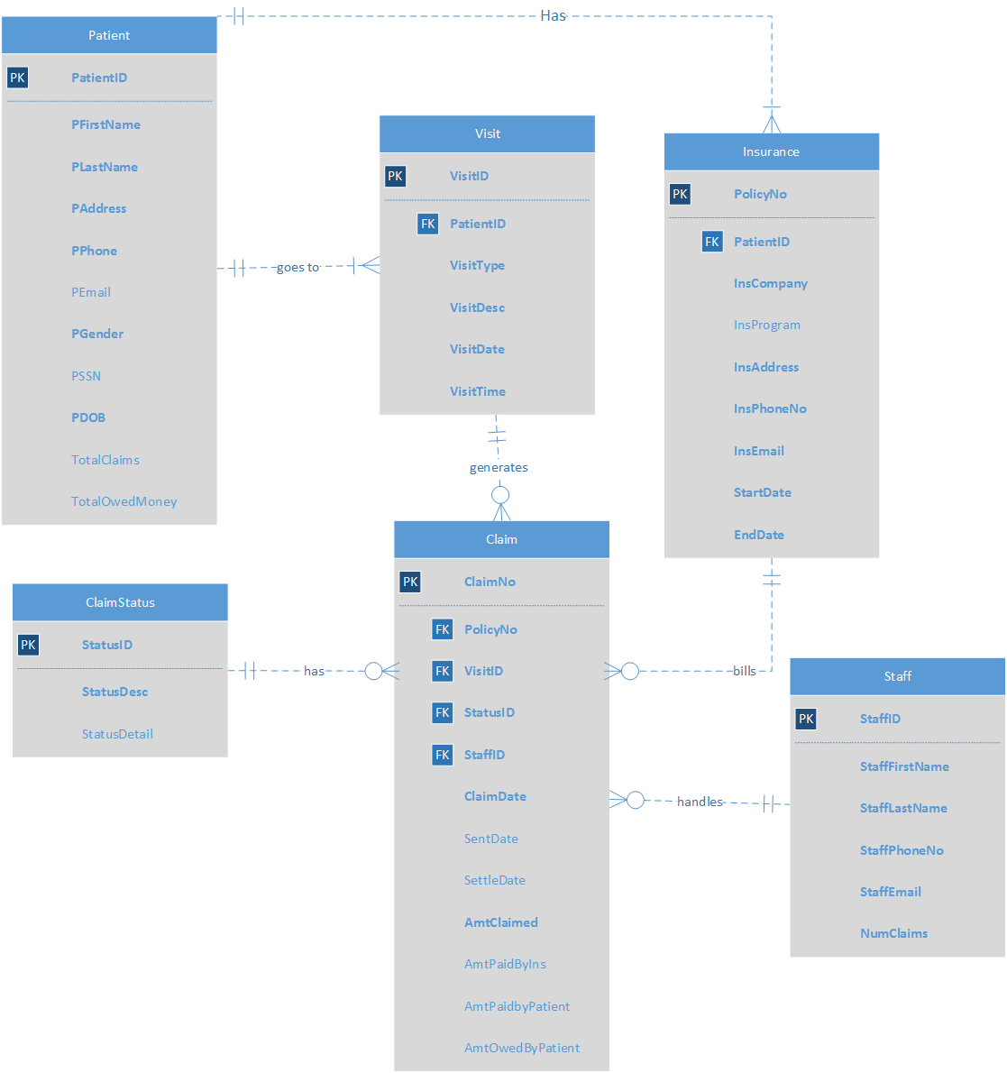

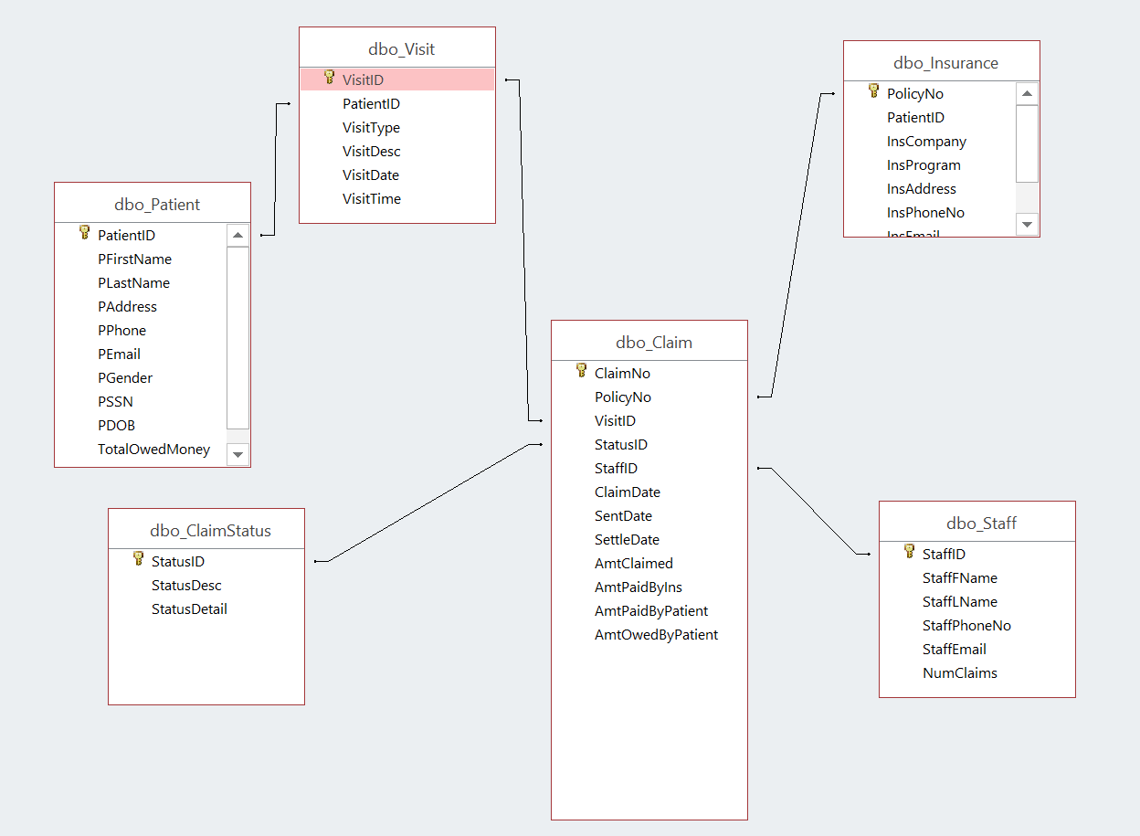

This is a revised version of the glossary table and ERD in your project design report. Your glossary should include explain the meaning of each entity, attribute, **and relationship between entities, including the real-world meaning of the degree and cardinality**. Include an example for each entity, attribute, or relationship if it is beyond comprehension based on common knowledge. In other words, all jargons you use in your report should be explained in this glossary.

All the required attributes are in **BOLD**

|  |  |
| --- | --- |
| Data object | Explanation |
| **Patient** | Patients’ personal information |
| PK: **PatientID** | Primary Key, Either DL/ID Number or Passport Number |
| **PFirstName** | Patients’ first name |
| **PLastName** | Patients’ last name |
| **PAddress** | Patient’s address |
| **PPhone** | Patient’s phone number |
| PEmail | Optional, patient’s email address |
| **PGender** | Patient’s gender |

|  |  |
| --- | --- |
| PSSN | Optional, patient’s Social security number |
| **PDOB** | Patient’s date of birth |
| TotalClaims | Optional, the total number of claims associated with a patient, the value is generated by a trigger. |
| TotalOwedMoney | Optional, the total amount of a patient’s unpaid balance, the value is generated by a procedure. |
| **Insurance** | Patients’ insurance information |
| PK: PolicyNo | Insurance Policy Number |
| FK: PatientID | Associates with PatientID in **Patient** Table, a patient could have one or more insurance policies, an insurance policy is only for one patient |
| InsCompany |  |
| InsProg | Insurance policy program |
| InsAddress | Insurance company address |
| InsPhoneNo | Insurance program phone number |
| StartDate |  |
| EndDate |  |
| **Visit** | Patients’ office visits information |
| PK: VisitID | Autogenerated |
| FK: PatientID | Associates with PatientID in **Patient** Table, a patient could have one or more visits, an office visit is only for one patient |
| VisitType | Type of visits, including Counseling, Medicine, Acupuncture, Cupping, and etc |
| VisitDesc | Describe the diagnosis/treatment |
| VisitDate |  |
| VisitTime |  |
| **NonInsuranceBill** | Non-Insurance bill: Medical bills not billable to the insurance company |
| PK: BillNo |  |
| FK: VisitID | Associates with VisitID in **Visit** Table, a visit could generate one or more visits, an office visit is only for one patient |

|  |  |
| --- | --- |
| FK: StaffID | Associates with StaffID in **Staff** Table, a Non-insurance bill is handled by one of the clinic staff, a staff member can handle multiple non-insurance bills |
| BillDate |  |
| BillAmt | The bill amount |
| BillDesc | Detailed Description on what the bill is about |
| PaidAmt | How much of the bill is paid |
| BillStatus | Whether the non-insurance bill is paid, paid in part, or not paid at all |
| BillPaidDate |  |
| **ClaimStatus** | Statuses of insurance claims |
| PK: StatusID |  |
| StatusDesc | Claim Status Description, which includes dispute, settled, not filed yet, pen |
| StatusDetail | Detailed description on what the status is about |
| **Staff** | Information about staff member including the doctor herself |
| PK: StaffID |  |
| StaffFirstName |  |
| StaffLastName |  |
| StaffPhoneNo |  |
| StaffEmail |  |
| **Claim** | Insurance Claim Information |
| PK: ClaimNo |  |

|  |  |
| --- | --- |
| FK: PolicyNo | Associates with PolicyNo in **Policy** Table, a claim can only be filed under one policy, a policy can have multiple claims |
| FK: VisitID | Associates with VisitID in **Visit** Table, a claim can only be filed for one policy, a visit can have multiple claims |
| FK: StatusID | Associates with StatusID in **ClaimStatus** Table, a claim can only have one status, a status could be from multiple claims |
| FK: StaffID | Associates with StaffID in **Staff** Table, a claim can only be filed by one staff, a staff can file multiple claims |
| ClaimDate | The date the claim is generated |
| SentDate | The date the claim is filed |
| SettleDate | The date the claim is settled |
| AmtClaimed | The amount asked by the clinic |
| AmtNegotiated | The final negotiated amount between the clinic and the insurance company |
| AmtPaidByIns | Amount of money paid by insurance |
| AmtPaidByPatient | Amount of money paid by the patient |

**Section IV**: SQL script for creating tables and inserting sample data. (2 points)

I will demonstrate the data-insertion by creating a patient called Chris Paul, who has two claims, and he paid one of them and has not paid the other one yet.

CREATE: Patient

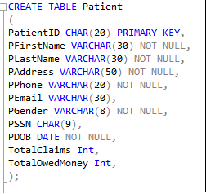

**Insert Data in PATIENT Table:**



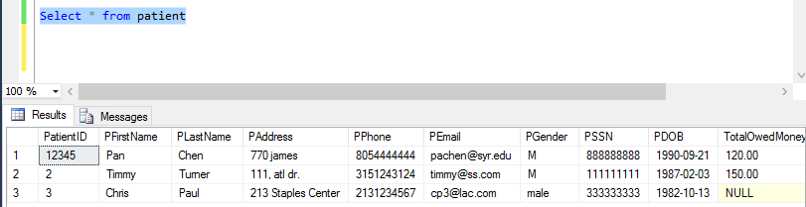

In this section please copy and paste the SQL script you used to create the tables and insert the sample data. Please refer to the instructor’s sample script as example. Your readers should be able to re-create and populate the database using this script. Add comments generously.

**Section V**: **SQL statements for answering major data questions using reports**. **Required to have at least one Data Question with Aggregate Functions** (2 points)

In this section please list all major data questions that your database users will ask, explain why they are the most important data questions for your database users, and provide the SQL statements to answer these questions. **Display the Reports that display the major Data Questions**. Your data questions should include some business intelligence questions. For complex queries, please add comments to explain how you come up with the solution. Include screen copy of the selected result. The screen copies and comments will help the instructor do the troubleshooting in case of errors in the statements. You should include some queries that use aggregation and categorization functions to demonstrate your ability in using them. You may also create views to store the queries and use them to create reports.

Some data operations may require more than one SQL statement. Don’t forget to create transactions in these cases.

**Section VI**: Interfaces (1 points)

Create forms (with at least one combo box) and reports for users to perform data input and output easily. Include the screen copy of all forms and reports. Add captions to explain the purpose of each form or report. You should generate reports for the major data questions in Section VI.

This is the homepage for my system:

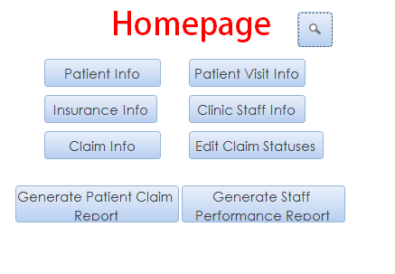

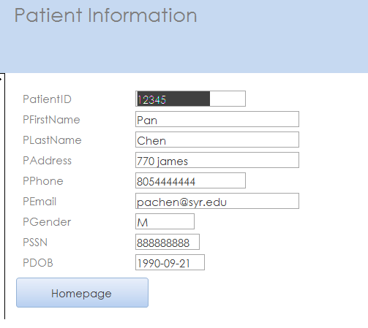

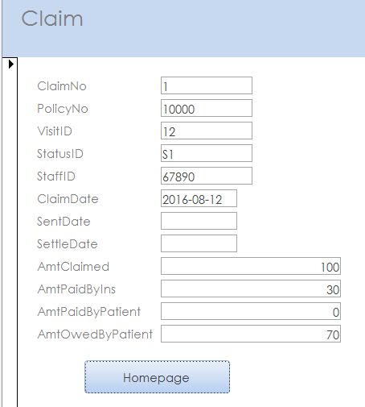

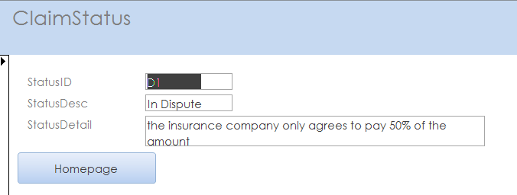

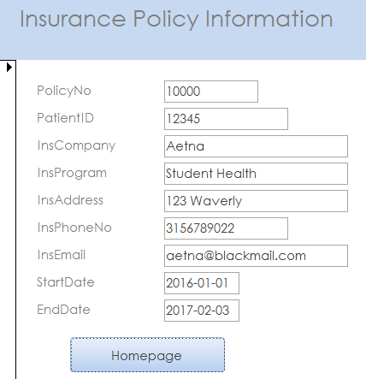

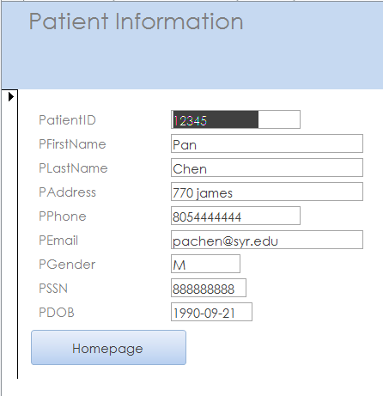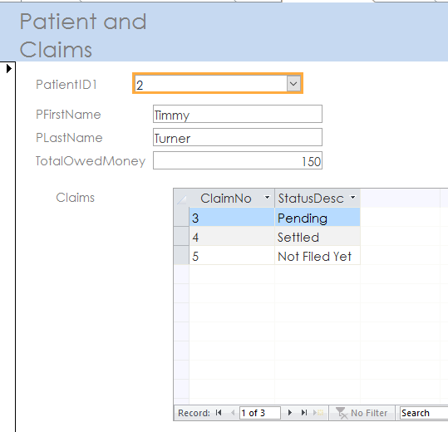

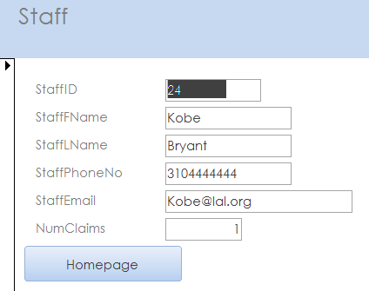

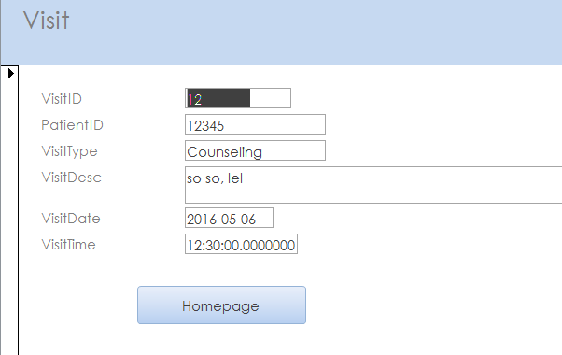

**Section VII**: Trigger (0.5 point)

Create a trigger and some transaction process. Show the original code, explain the logic, and attach the results after executing the code.

**This trigger updates the number of claims from patients when a new claim entry is created or deleted**

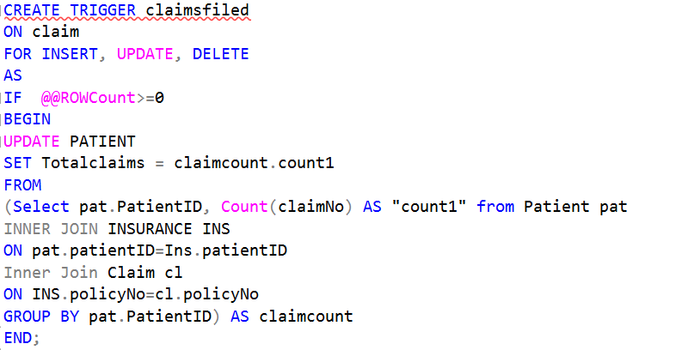

**Section V**: **business rules that are not represented in the above data model**

1. Each patient has to have an insurance policy, each policy number belongs to one patient, however it is up to the patient whether to use the insurance or not.
2. Claim Status Description(StatusDesc) can only be one of the four values: “D” stands for dispute, “S” stands for settled, “N” stands for not-filed -yet, “P” stands for pending.
3. Non-Insurance Bills can only be one of the four values: “O” stands for owed (paid in part), “S” stands for Settled, “N” stands for not-paid-yet.